
Pre-task:
Hello!
I’m BEAN.
New Words to Pre-teach/Learn:
Hotel, reception, check in, fill a form, suitcase,
bellhop (bellboy U.K), guest, elevator (lift U.K),
forget, button, steering wheel, remote control, corridor, pretend, drawer, change, drill, switch, receptionist, tips, I.D card, Driver’s license, passport
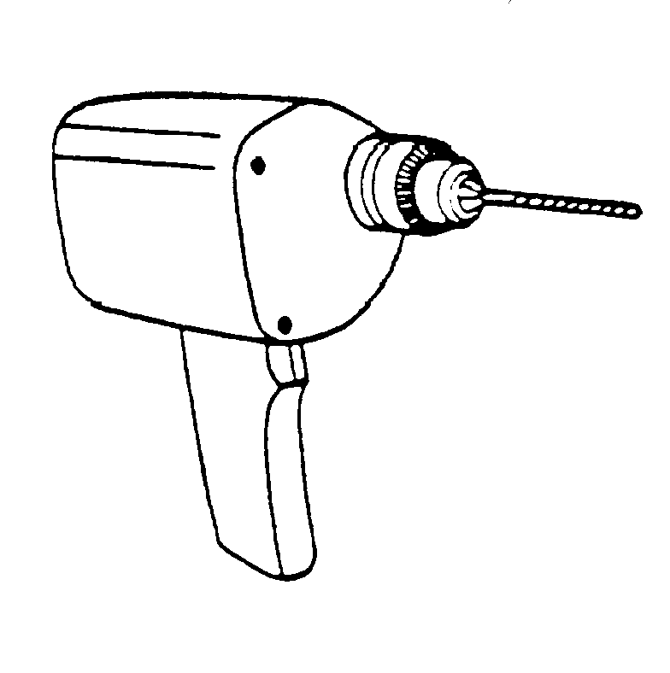
drill
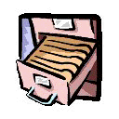
Draw_ _

Remote
c_ _ _ _ _ _

Suit_ _ _ _
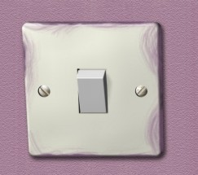
Light
sw _ _ _
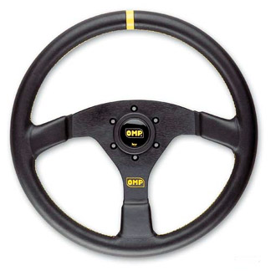
Steering
wh_ _l

Discussion
- What do you do when you first arrive at the hotel?
- Who do you usually meet at the reception?
- What do people do at the reception when they first arrive at the hotel?
- Have you ever checked into a hotel?
- What information do people usually fill into the form at the reception?
- What things do people usually take along when they travel?

Task(Watching & Answer Questions)( pause after every 5 questions)
- What does Mr. Bean want to do at the hotel reception?
- What does the bellhop want from him?
- What does Mr. Bean do with the switch?
- Who gets into the room first? Mr. Bean or the other guest?
- What does he hear when he picks up the phone?
- What was Mr. Bean doing before the bellhop knocked on his door?
- Why does the bellhop clear his throat? What does he want?
- What does Mr. Bean think he wants? What does he offer him?
- What device does Mr. Bean find on the TV? What is it used for?
- Who comes out to the corridor and why?
- What does Mr. Bean pretend to do?
- What does he take out of his suitcase? Where does he put it? What happens?
- What other things does he take out of his suitcase?
- How does he get the picture on to the wall? What does he use?
- Why can’t he find a place to put his towel?
- How does he get into his neighbor’s bathroom?
- Why can his neighbor not get into his bathroom?

Post-watching Task: Work in groups and create dialogues for the receptionist, Mr. Bean and the bellhop. What did they have to say that they didn’t say in the movie? Role play what you created.

Mr. Bean in Room 426 Part 1

Time: Estimated 40 mins. To 1 hour.
Level: pre-intermediate/intermediate
Grammar focus: present perfect using ever,
simple past, future tenses.
Language Focus: Survival English, Travel activities
& talking about holiday etc.
Warmer: (5- 10 mins)
Ask students to talk about the things they do during holidays. Play the “Freeze” ball game.
“Freeze” ball game rules:

- Students stand in a circle and the teacher gives them a ball.
- Teacher throws a ball to one student and asks the student to pass it to the next student very quickly until the teacher says “freeze”. If the teacher says freeze the student holding the ball cannot pass the ball. S/he must answer five questions about holidays which the teacher will ask.
- When the student answers the questions then game continues. If s/he can’t answer, then other students can help.
- To make it more fun the teacher can close his/her eyes and pretend to sleep while the ball is being passed around. The without warning s/he shouts “freeze” suddenly. The student with the ball must answer the teacher’s questions.
- After two rounds it is good to give the asking question role to the other students. If the class is small I usually ask everyone to ask the student with the ball at least one question related to the topic ( in this case holidays)

The following are some questions that can get students started?

- Where did you spend you last holiday?
- What did you do in this place you went to?
- How did you get there?
- Who did you go with?
- Where did you spend the night?
- Have you ever been to Australia?
- Have you ever tried bungee jumping?
- What was your most memorable holiday? Why?

Task Guide: Pre-teach vocabulary(ask students to cross out the ones they know. After that watch the video using the pause method(pause after 5 questions). Teacher asks a student to read the question and another answers.
After watching and answering the questions, tell the students to create dialogues for the characters in the movie.

