Indiana Jones , Raiders of the lost Ark.
- Vocabulary :
Whip, skeleton, tarantula, statue, boulder, escape, collapse, scared, jungle, booby traps, cave, helper, bag of sand, golden Idol, inhabitants
- Grammar focus:
Past tenses, adjectives followed by prepositions – afraid of, scared by, frightened by, reported speech
Fill in the blanks with the simple past tense of the following verbs.
- Take________Kill ________ say________Replace___________Escape__________Chase_______
See ________Take away_________Do__________collapse___________

C- Questions:
- What did one of Dr. Jones’ helpers try to do with the gun?
- _______________________________________
- Did he succeed to kill Indiana Jones? Why? ___________________
- What did Indiana Jones use to knock the gun from the man’s hand?
- ___________________________________________
- What did Indiana Jones put in the bag before getting into the cave?
- _______________________________________________
- What was the man frightened by?
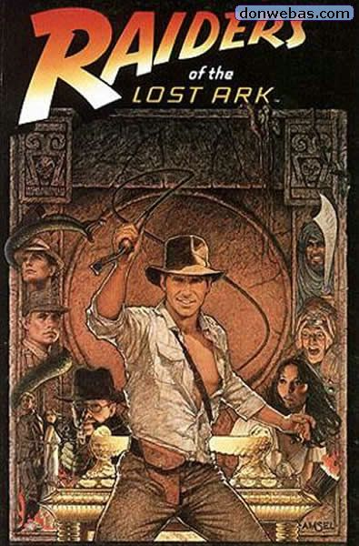
- ______________________________________________
- What happened when his helper tried to cross over the hole?
- ____________________________________________
- What did Indiana Jones replace the golden statue with?
- _______________________________________
- What happened when he took the statue?
- ____________________________________________
- What did his helper do to get the idol from him?
- ___________________________________________
- What did Indiana Jones do to get across the big hole?
- ________________________________________
- What had happened to his helper when he got out?
- ___________________________________________
- What was Indiana Jones escaping from after taking the statue from the dead helper?
- _______________________________________________
- What happened when he got out of the cave?
- ________________________________________________
- Did he keep the golden idol? Why?
- ____________________________________________
- How did he escape from the forest inhabitants?
- ___________________________________________
- What did he see in the plane? What did he say when he saw it? (put it into reported speech)
- ___________________________________________________

D- Student task:
In groups of three retell the story of the movie using comic strips.

