Harry Potter and the Chamber of Secrets
Worksheet 2

VOCABULARY
trolley 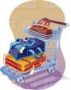 castle 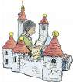 greenhouse 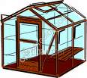 earmuffs 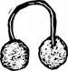
ghost  slug  steering wheel 

If a student behaves badly, he might have to stay at school after the classes and do some work. It’s called d _ _ _ _ _ _ _ _ (eeiotdntn).

If a student behaves very badly, he might have to leave school forever. He might be e _ _ _ _ _ _ _ (xlpdelee).

There are four Houses in the Hogwarts School: Gryffindor, Slytherin, Ravenclaw, and Hufflepuff.

QUESTIONS
- What time was it when they arrived at the train station?
- What time did the train leave?
- What side was the steering wheel on?
- What happened to the car?
- What did the tree (Whomping Willow) do?
- What pet did Ron have in the cage?
- Were Harry and Ron expelled from the school?
- What punishment were they given?
- How did Ron repair his wand?
- Did boys like the new teacher? Did girls?
- Was he a good teacher?
- Who was the new player on Slytherin team?
- What happened to Ron?
- What did Draco Malfoy tell Hermione? What did it mean?
- What did Harry have to do for his detention?
- What did he hear in the corridor?

